Member ID: ____________________
Time: ___________________
Rank: _______________



ADVANCED COLLEGE ACCOUNTING
(115)
NATIONAL 2024

CONCEPT KNOWLEDGE:

Multiple Choice (25 @ 2 points each) (50 points)

APPLICATION KNOWLEDGE:
Short Answer (11@ 4 points each) (44 points)
Problem 1: (18 @ 2 points each) (36 points)
Problem 2: (24 @ 2 points each) (48 points)
Problem 3: (33 @ 2 points each) (66 points)
TOTAL POINTS (244 points)

Test Time: 90 minutes

GENERAL GUIDELINES:
Failure to adhere to any of the following rules will result in disqualification:
- Member must hand in this test booklet and all printouts if any. Failure to do so will result in disqualification.
- No equipment, supplies, or materials other than those specified for this event are allowed in the testing area. No previous BPA tests and/or sample tests (handwritten, photocopied, or keyed) are allowed in the testing area.
- Electronic devices will be monitored according to ACT standards.
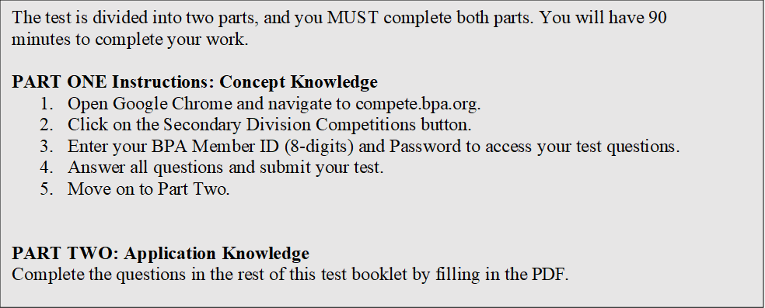
EXAM GUIDELINES:

You have been hired as a Financial Assistant and will be keeping the accounting records for Digital Solutions, located at 700 Morse Road, Suite 201, Columbus, Ohio 43214. Digital Solutions provides accounting and other financial services for clients. You will complete jobs for Digital Solutions’ own accounting records, as well as for clients.

You will have 90 minutes to complete your work. The test is divided into two parts: concept knowledge and application knowledge.

Your name and/or school name should not appear on any work you submit for grading. Write your Member ID in the provided space. Staple all pages in order before you turn in your test.

Assumptions to make when taking this assessment:
- Round all calculations at the final step.
- Round all percentages to one decimal place.
- Use 360 days for interest calculations.
Short-Answer Questions
#1 – (12 points, 4 points for each answer)
The following table shows the future value factors of $1.
Periods | 2% | 4% | 8%
1 | 1.02000 | 1.04000 | 1.08000
2 | 1.04040 | 1.08160 | 1.16640
3 | 1.06121 | 1.12486 | 1.25971
4 | 1.08243 | 1.16986 | 1.36049
5 | 1.10408 | 1.21665 | 1.46933
6 | 1.12616 | 1.26532 | 1.58687
7 | 1.14869 | 1.31593 | 1.71382
8 | 1.17166 | 1.36857 | 1.85093

Using the above table, calculate the present value of $100,000 under the following scenarios:
- Invested for 2 years, compounded quarterly, at 8%. _______
- Invested for 2 years, compounded annually at, 8%. _______
- Invested for 2 years, compounded semiannually, at 8%. _______

#2 – (12 points, 4 points for each answer)
The following table shows the present value factors of $1.
Periods | 2% | 4% | 8%
1 | 0.98039 | 0.96154 | 0.92593
2 | 0.96117 | 0.92456 | 0.85734
3 | 0.94232 | 0.88900 | 0.79383
4 | 0.92385 | 0.85480 | 0.73503
5 | 0.90573 | 0.82193 | 0.68058
6 | 0.88797 | 0.79031 | 0.63017
7 | 0.87056 | 0.75992 | 0.58349
8 | 0.85349 | 0.73069 | 0.54027

Using the above table, calculate the present value of $100,000 under the following scenarios:
- Invested for 2 years, compounded semiannually, at 8%. _______
- Invested for 2 years, compounded quarterly at, 8%. _______
- Invested for 2 years, compounded annually, at 8%. _______

#3 – (20 points, 4 points for each answer)
On July 31, 2022, Corbridge Company sells (with recourse) a customer’s note at its bank at a 10% discount rate. Corbridge received the note from the customer on July 1. The note is for 90 days, has a face value of $25,000 with an interest rate of 8%. The estimated value of the recourse liability is $1,500. The customer pays the note on its maturity date, September 30, 2022.
- If Corbridge holds the note until maturity, what would the maturity value be? _______
- When Corbridge sells the note to the bank, what is the discount amount? _______
- What proceeds with Corbridge receive? _______
- What is the interest income Corbridge receives on July 31? _______
- What is the amount of recognized a gain or (loss) on July 31? _______

PROBLEMS
Problem #1– (36 points, 18 @ 2 points each, no points for date)
Thompson Corporation issued $1 million of 10% bonds for $962,311.87. The bonds were dated and issued July 1, 2021 with semiannual interest payments on June 30 and December 31. The bonds will mature in 5 years. The market rate at the time the bonds were issued was 11% and the company uses the effective interest amortization method.
Prepare the journal entries for:
- The bond issuance on July 1, 2021,
- The payment of interest on December 31, 2021, and
- The payment of interest on June 30, 2022.
Date | Accounts | Debit | Credit

Problem #2 – (48 points, 24 @ 2 points each, no points for date)
Joplin Corporation is authorized to issue 20,000 shares of $5 par common stock. During the year, Joplin had the following transactions:
Jan. 10 Issued 10,000 shares of common stock at $20 per share.
Mar. 31 Reacquired 1,000 shares of common stock as treasury stock at $13 per share.
July 1 Reissued 600 shares of treasury stock at $15 per share.
Nov. 1 Retired the remaining 400 shares of treasury stock.

Date | Accounts | Debit | Credit

Problem #3 – (66 points, 2 points each correct title and amount)
The comparative balance sheets of Capitol Company, for Years 1 and 2 ended December 31, appear below in condensed form.
 | Year 2 | Year 1
Cash | $ 45,000 | $ 53,500
Accounts Receivable (net) | 51,300 | 58,000
Inventories | 147,200 | 135,000
Investments | 0 | 60,000
Equipment | 493,000 | 375,000
Accumulated Depreciation—Equipment | (113,700) | (128,000)
 | $622,800 | $553,500
Accounts Payable | 54,500 | $32,600
Deferred Income | 7,000 | 10,000
Bonds Payable, Due Year 4 | 0 | 100,000
Common Stock, $10 par | 250,000 | 200,000
Paid-In Capital in Excess of Par—Common Stock | 75,000 | 50,000
Retained Earnings | 236,300 | 160,900
 | $622,800 | $553,500
​

The income statement for the current year is as follows:
Sales |  | $623,000
Cost of merchandise sold |  | 348,500
Gross profit |  | $274,500
Operating expenses:
Depreciation expense | $24,700
Other operating expenses | 75,300 | 100,000
Income from operations |  | $174,500
Other revenue and expense:
Gain on sale of investment | 5,000
Interest expense | (12,000) | (7,000)
Income before income tax |  | $167,500
Income tax expense |  | 64,100
Net income |  | $103,400

Additional data for the current year are as follows:
(a) | Fully depreciated equipment costing $39,000 was scrapped, no salvage, and equipment was purchased for $157,000.
(b) | Bonds payable for $100,000 were retired for cash at their face amount.
(c) | 5,000 shares of common stock were issued at $15 for cash.
(d) | Cash dividends declared were paid, $28,000.
(e) | All sales are on account.
(f) | Sold long-term investment for $65,000 cash.
​
Prepare a statement of cash flows using the indirect method of reporting cash flows from operating activities.

Capitol Company
Statement of Cash Flows
For the Year Ended December 31, Year 2
Cash flows from operating activities:
Noncash items:
Changes in operating items:
Net cash flow from operating activities
Cash flows from investing activities:
Net cash flow from investing activities
Cash flows from financing activities:
Net cash flow from financing activities

